- Diagrams

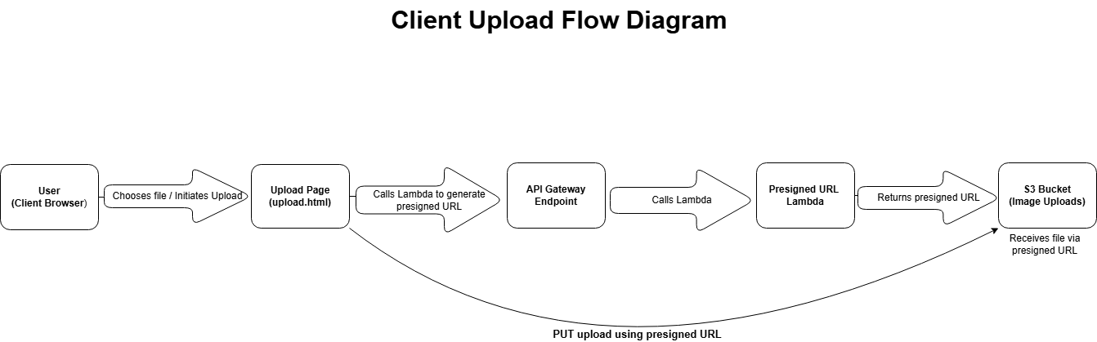

This diagram shows how the user uploads an image through a simple HTML page. The page requests a presigned URL from API Gateway, which triggers a Lambda function to generate that URL. The browser then uses the presigned URL to upload the file directly to the S3 bucket. This upload is the starting point for the entire processing pipeline.

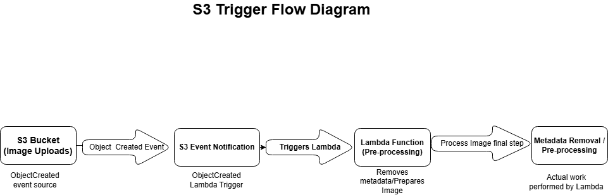

This diagram shows what happens after a file is uploaded to the S3 bucket. When S3 detects a new object, it generates an ObjectCreated event. That event is passed to an S3 Event Notification, which triggers a Lambda function. The Lambda performs the initial preprocessing step, such as removing metadata or preparing the image for further processing. This automated trigger ensures that every upload immediately enters the processing pipeline.

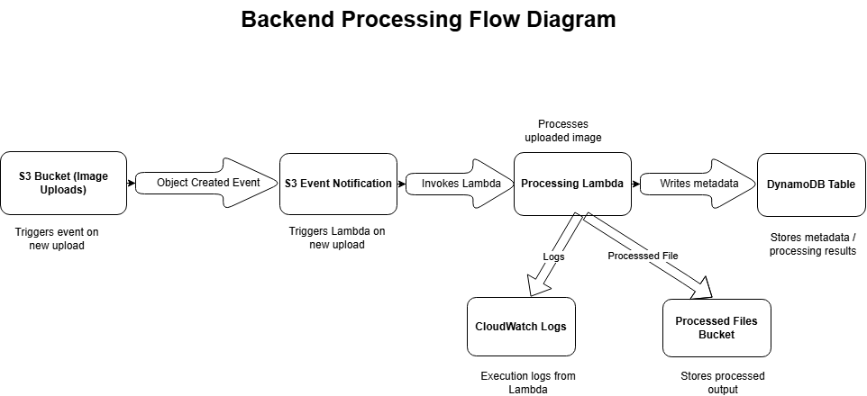

This diagram shows what happens after the preprocessing step. The Processing Lambda performs the main work on the uploaded image and then stores the results in a DynamoDB table. At the same time, it sends execution logs to CloudWatch Logs and saves any processed output files into a separate S3 bucket. Together, these components complete the backend pipeline by storing results, keeping logs, and preserving processed files.

- Short description of upload interface (the trigger)
The upload interface is a simple, client-side HTML page that allows a user to select an image and upload it directly to the S3 bucket using a presigned URL. The page uses JavaScript to request a fresh presigned URL from the API Gateway endpoint and then performs a secure PUT request to S3. This interface serves as the entry point to the entire image-processing pipeline.

- Link to working upload page
https://it261-marianne-image-bucket.s3.us-west-2.amazonaws.com/upload.html

This link opens the live upload interface, which successfully uploads images to the designated S3 bucket and triggers the backend pipeline.

- A brief explanation of the presigned URL flow
When the user selects an image, the upload page calls the API Gateway endpoint, which invokes the presigned-URL Lambda function. That Lambda generates a temporary, permission-limited URL that allows the browser to upload the file directly to S3 without exposing AWS credentials. The browser then performs a PUT request to the presigned URL, placing the file into the S3 bucket and triggering the backend processing pipeline.

